Date: May 29, 2022

mspeidel-data models assignment 1_4

Subject: Michele Speidel Module 1_4 Data Models

1. Translate the following business rules into an object relational diagram (ORD) using UMLet
   1. a USER has many ROLES
   2. a USER has one BIRTHDATE
   3. a USER can have many DEPENDENTS

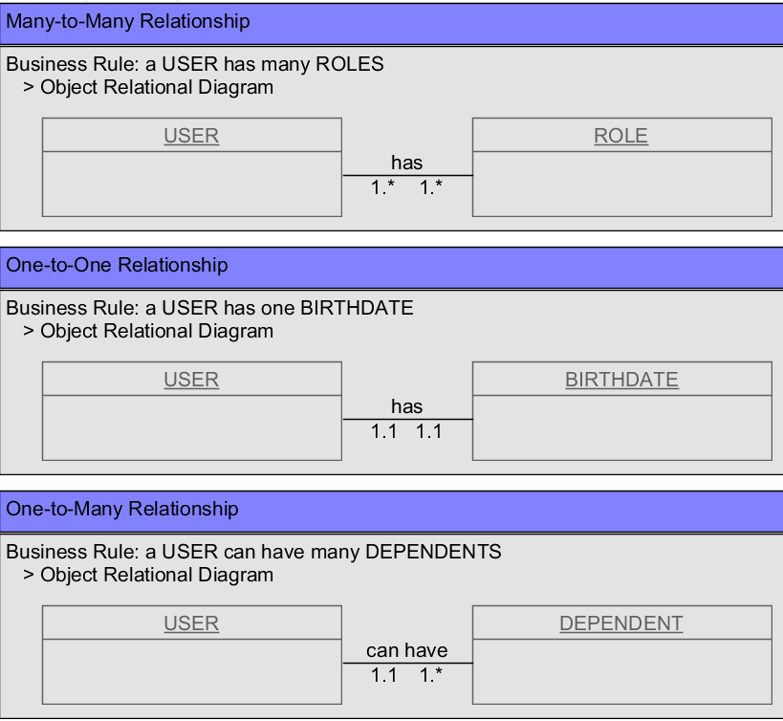

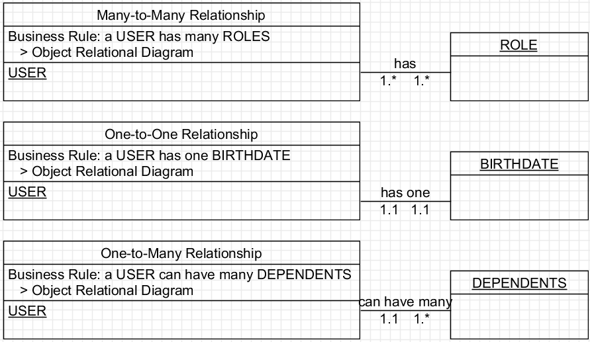

1. Convert the translated diagrams into NoSQL data structures

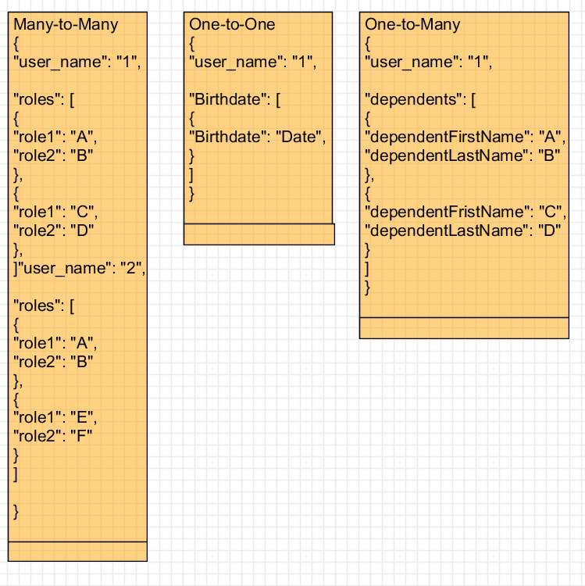

= = =

Many-to-Many

{

"user_name": "1",

"roles": [

{

"role1": "A",

"role2": "B"

},

{

"role1": "C",

"role2": "D"

},

]"user_name": "2",

"roles": [

{

"role1": "A",

"role2": "B"

},

{

"role1": "E",

"role2": "F"

}

]

}

= = =

One-to-One

{

"user_name": "1",

"Birthdate": [

{

"Birthdate": "Date",

}

]

}

= = =

One-to-Many

{

"user_name": "1",

"dependents": [

{

"dependentFirstName": "A",

"dependentLastName": "B"

},

{

"dependentFristName": "C",

"dependentLastName": "D"

}

]

}